**PROBLEM 1:** *Write a program to print your name* on screen.  
Steps:  
1- print "Abdallah".

**PROBLEM 2:** *Write a program to ask the user to  
 print his/her name and print it on screen.*  
Steps:   
1- Ask the user to enter his/her name.  
2- Print the entered name.  
  
  
  
  
  
  
  
  
  


**PROBLEM** 3: *Write a program to ask the user to enter a number, then print* “ODD” if it is odd or “EVEN” if it’s even.  
Steps:  
1- Ask the user to enter a number.   
2- Result= number mod 2.  
3- If the result= 0 then it’s even   
otherwise it’s odd   
4- Print “even” or “ODD” according to   
step 3.



**PROBLEM 4:** *DIRVER LICENSE CASE 1  
Write a program to ask the user to enter his/her:  
1-Age.  
2-Driver license.  
 Then print “hired” if the Age   
is greater 21   
and s/he has a driver license, otherwise print “rejected”.*Steps:  
1-ask the user to print his/her age.  
2-ask if s/he has a driver license.  
3-Result= (age> 21 and   
has a driver license TRUE)   
4- Check if the result= TRUE  
then hire, otherwise reject.   
5- Print “HIRED” or   
 print “REJECTED” accordingly.

**PROBLEM 5:** *DIRVER LICENSE CASE 2  
Write a program to ask the user to enter his/her:  
1-Age.  
2-Driver license.  
3- Has a Recommendation!   
Then print “hired” if the Age  
 is greater 21 and s/he has a driver license,  
  
 otherwise print “rejected”.   
Or hire him/her without  
conditions.*



**PROBLEM 6:** *Write a program to ask the user to enter:  
1-First name.  
2-Last name.   
Then print full name   
on the screen.*  
Steps:  
1- Ask the user to enter  
the FirstName.  
2- Ask the user to enter   
the LastName.  
3- Fullname=  
 Firstname+” ”+ LastName.  
  
  
  
4- Print FullName.  


**PROBLEM 7:** *Write a program to ask the user to enter:  
- Number  
Then print the “Half of   
the <Number>is <???>”.*  
Steps:  
1- Ask the user to enter   
the Num.  
2- HalfNumber= Number/2.  
3- R= “Half of number “+ NUM+ “ is “+   
HalfNumber.   
  
  
4- Print R.

**PROBLEM 8:** *Write a program to ask the user to enter:  
- Mark  
Then Print “PASS” if the  
 mark>= 50, otherwise  
 print “Fail.*Steps:  
1- Ask the use to enter the Mark.  
2 – If mark >= 50 PASS, otherwise   
Fail.  
3- Print “PASS” or “Fail” accordingly.

**PROBLEM 9:** *Write a program to ask the user to enter:  
- Number1, Number2, Number3.  
Then print the sum of entered numbers.*Steps:   
1- Ask the use to enter Num1, Num2, Num3.  
2- Sum= Num1+ Num2+ Num3.  
3- Print Sum.

**PROBLEM 10:** *Write a program to ask the user to enter:  
-Mark1, Mark2, Mark3.  
Then Print the average of the entered   
Marks*Steps:  
1- Ask the user to enter   
Mark1, Mark2, Mark3.  
2- Avg= (Mark1+ Mark2+ Mark3)/3.  
3- Print Avg.

**PROBLEM 11:** *Write a program to ask the user to enter:  
- Mark1, Mark2, Mark3.  
Then print the Average of entered marks,   
and Print “PASS” if the Avg>=50, otherwise  
 Print “Fail”.*Steps:   
1- Ask the user to enter  
Mark1, Mark2, Mark3.  
2-Avg= (Mark1+ Mark2+ Mark3)/3.  
3- If Avg >=50 “PASS”, otherwise   
“Fail”.  
4- Print “PASS” or “Fail” accordingly.

**PROBLEM 12:** *Write a program to ask user to enter:  
- Number1, Number2.  
Then Print the Max Number.*Steps:  
1- Ask the user to enter Num1, Num2.  
2- If Num1> Num2, Then Num1  
is Max, otherwise  
Num2 is Max.  
3 – Print Max accordingly. 

**PROBLEM 13:** *Write a program to ask the user to enter 3 Numbers:  
- A.  
- B.  
- C.  
Then Print Max Number.*Steps:   
1- Ask the user to Print 3 numbers.  
A, B, C.  
2- If A>B>C, then A is Max.  
If B>A>C, then B is Max.  
If C>A>B, then C is Max.  
3- Print Max accordingly.  


**PROBLEM** 14: *Write a program to ask the user to enter:*  
- Number1.  
- Number2.   
Then print the two numbers, then swap  
the two numbers then print them.  
Steps:  
1- Ask the user to enter  
Num1, Num2.  
2- Print Num1.  
3- Print Num2   
4- Temp= Num1.  
 Num1= Num2.  
Num2=Temp.  
5- Print Num1 and Print Num2.  
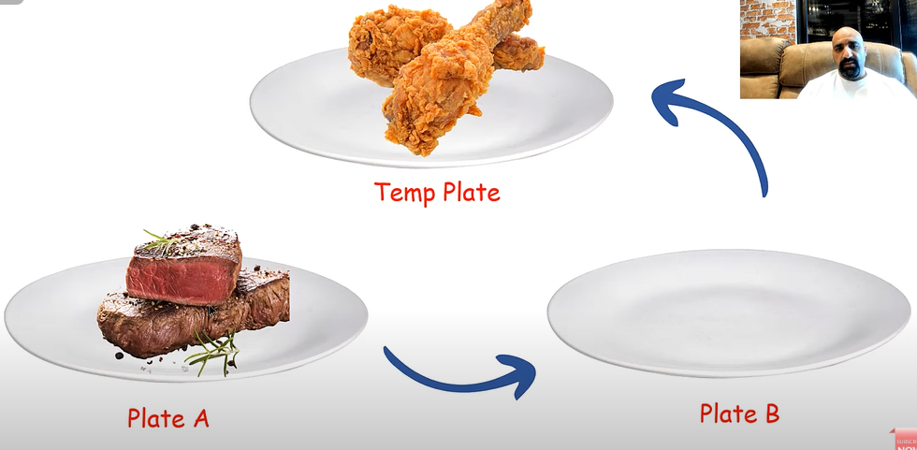  
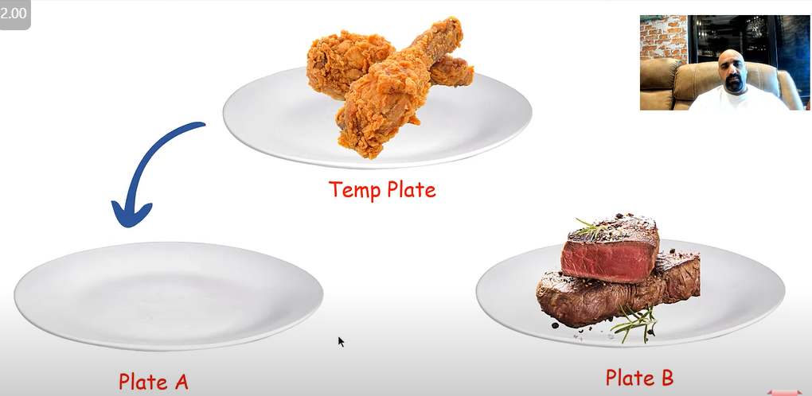  
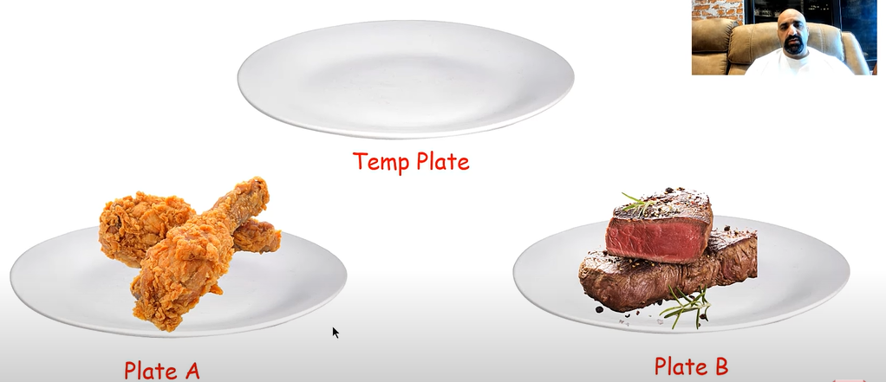  




**PROBLEM 15:** *Write a program to calculate rectangle area and* *print it on screen*.  
Steps:  
1- Ask the user to enter a, b.  
2- Area= a * b.   
3- Print Area. 

**PROBLEM 16**: *Write a program to calculate the rectangle area through diagonal and side area of rectangle and print it on screen.*  
Steps:  
1- Ask the user to enter a, b.  
2- Area= a * sqrt(d*d-a*a)  
3- Print Area. 

**PROBLEM 17***: Write a program to calculate triangle area and print it on screen.*Steps:  
1- Ask the user to enter a, h.  
2- Area= (a/2) * h.  
3- Print Area.

**PROBLEM 18:** *Write a program that calculate the circle area then print it on screen.*Steps:   
1- Ask the user to enter r.  
2- PI= 3.14  
3- Area= PI(r * r).  
4- Print Area.



**PROBLEM 19:** *Write a program that calculate  
 the circle area through diameter, then print it on screen.*Steps:   
1- Ask the user to enter D.  
2- PI= 3.14  
3- Area= ( PI * D * D ) / 4  
4- Print Area.

**PROBLEM 20:** *Write a program to calculate circle area inscribed in a square, then print it on screen.*

Steps:  
1- Ask the user to enter A. .  
2- PI=3= 3.14 .  
3- Area= PI * A * A / 4.4- Print Area.

**PROBLEM 21:** *Write a program to calculate the circle are along the circumference then print it on screen.* Steps:   
1- Ask the user to enter L.  
2- PI.  
3- Area= L * L / (4π)**.**  
4- Print Area.  




**PROBLEM 22:** *Write a program to calculate circle area inscribed in an isoceles triangle, then   
print it on screen.* Steps:   
1- Ask the user to enter a and b.   
2– PI= 3.14 .   
3- Area=  
( (PI * b * b) / 4 ) * ( (2 * a – b) / (2 * a + b) ).  
4- Print Area. 

**PROBLEM 23:**  *Write a program to calculate circle area circle described around an arbitrary triangle, then print it on screen.  
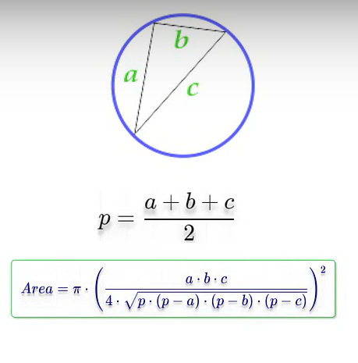*Steps:  
1- Ask the user to enter:   
a, b and c.  
2- PI= 3.14 .  
3- p= ( a + b + c ) / 2  
4- T= (a * b * c) /   
(4 * sqrt (p * (p-a) * (p-b) * (p-c) )) .  
5- T= T * T.  
6- Area= PI * T  
7- Print Area



**PROBLEM 24:**  *Write a program to ask the user to enter:  
- Age  
If Age is between 18 and 45, print “Valid Age”, otherwise print “Invalid Age”.*Steps:  
1- Ask the user to enter  
 his/her age.  
2- Result  
=( Age>= 18 and Age<= 45).  
3- Chek if Result= True, then  
 Age is valid, otherwise invalid.  
4- Print “Valid Age”  
 or  
 “Invalid Age” accordingly.**PROBLEM 25:**  *Write a program to ask the user to enter:  
- Age  
If Age is between 18 and 45, print “Valid Age”, otherwise print “Invalid Age” and re-ask the user to enter a valid age.***Note: You should keep asking the user to enter a valid age until s/he enter it.**Steps:  
1- ask the user to enter his/her Age.  
2- Result=( Age>= 18 and Age<= 45)  
3- Check if Result= True print “Valid Age”.  
4- Check if Result= False print “Invalid Age”  
and go to step 1.   










**PROBLEM 26:**  *Write a program to print numbers from 1 to N.*  
  
  
Steps:  
1- Ask the user to enter N.  
2- Counter= 0.  
3- Counter= Counter + 1.  
4- Print Counter on screen.  
5- If Counter= N, then   
stop, otherwise go to step 3.

**PROBLEM 27:**  *Write a program to print numbers from N to 1.*Steps:  
1- Ask the user to enter N.  
2- Counter= N.  
3- Counter= N + 1.  
4- Counter= N - 1  
5- Print Counter on the screen.  
6- If Counter= 1, then   
stop, otherwise go to step 3.  
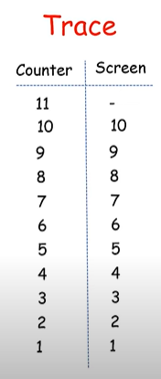

**PROBLEM 28:**  *Write a program to sum odd numbers   
from 1 to N.  
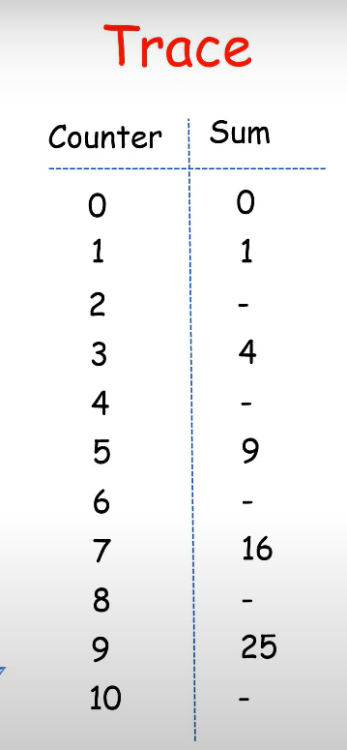*Steps:  
1- Ask the user to enter N.  
2- Counter= 0.  
3- Sum=0.  
4- Counter= N + 1.  
5- R= Counter mod 2 <>0.  
6- If R= True ,then  
 Sum= Sum + Counter  
, otherwise   
If Counter<> N go to step 4,  
if counter= N, then print Sum.  


**PROBLEM 29:**  *Write a program to sum even numbers from 1 to N.*Steps:  
1- Ask the user to enter N.  
2- Counter= 0.  
3- Sum=0.  
4- Counter= N + 1.  
5- R= Counter mod 2= 0.  
6- If R= True ,then  
 Sum= Sum + Counter  
, otherwise   
If Counter<> N go to step 4,  
if counter= N, then print Sum.





**PROBLEM 30:**  *Write a program to calculate the factorial of N.  
Example: factorial of 6 is 6 x 5 x 4 x 3 x 2 x 1 = 720  
Note: user should enter positive number, otherwise rejecte it and ask to enter again.*Steps:   
1- Ask the user to enter N.  
2- Chek if N<=0?  
3- If N<=0 True go to step 4  
,otherwise Print  
 “Factorial Must  
 Be Positive Number”  
and go to step 1.  
4- Counter= N + 1.  
5- Factorial= 1.  
6- Counter= N – 1.  
7- Factorial=  
 Factorial * Counter.  
8- If Counter= 0   
,then stop   
and print Factorial,   
otherwise go to step 6.  


**PROBLEM 31:**  *Write a program to ask the user to enter:  
- Number.  
Then print the Number^2, Number^3, Number^4.*Steps:  
1- Ask the user to enter N.  
2- A= N * N.  
3- B= N * N * N.  
4- C= N * N * N * N.  
5- Print A, B, C.





**PROBLEM 32:**  *Write a program to ask the user to enter:  
- Number.  
- M.  
Then print Number^M.  
* 

**PROBLEM 33:**  *Write a program to ask the user to enter:  
- Grade.  
Then print grades as flollows:  
 90 – 100 Print A  
80 – 89 Print B  
70 – 79 Print C  
60 – 69 Print D  
50 – 59 Print E  
Otherwise Print F*





**PROBLEM 34:**  *Write a program to ask the user to enter:  
- Totalsales  
The comission is calculated as one percentage * the total sales amount, all you need is to decide which percentage to use of the following:  
1000,000 🡪 Percentage is 1%  
500K to 1M🡪 Percentage is 2%  
100K to 500K 🡪 Percentage is 3%  
50K to 100K🡪 Percentage is 5%  
Otherwise 🡪 Percentage is 0%*

**PROBLEM 35:**  *Write a program to ask the user to enter:  
- Pennies, Nickels, Dimes, Quarters, Dollars.  
Then calculate the total pennis, dollars and print them on screen giving that:  
- Penny= 1 Penny.   
- Nickel= 5 Penny.   
- Dime= 10 Penny.  
- Quarter= 25 Penny.  
- Dollar= 100 Penny.*



**PROBLEM 36:**  *Write a program to ask the user to enter:  
- Number1.  
- Number2.  
- Operation Type.  
Then perform the calculating according to the Operation Type   
of follows:  
1- “+“ :Add the two numbers.  
2- “–“ :Subtract the two numbers.  
3- “*“ :Multiply the two numbers.  
4- “/“ : Devide the two numbers.*

























**PROBLEM 37:**  *Write a program to read numbers from user and sum them, keep reading until the user enter -99 then print the sum on screen.*





**PROBLEM 38:**  *Write a program to read a number and check if it is a prime number or not.  
Remmber: Prime number can only divide on one and on itself.*

**PROBLEM 39:**  *Write a program to read a TotalBill and CashPaid and calculate the remainder to be paid back.*





**PROBLEM 40:**  A resaurant charges 10% services fee and 16% sales tax.  
*Write a program to read a BillValue and add services fee and sales tax to it, and print to TotalBill on the screen.*

**PROBLEM 41:**  *Write a program to read a NumberOfHours and calculates the number of weeks, and days included in that number.*





**PROBLEM 42:**  *Write a program to calculate the task duration in seconds and print it on screen.  
🡪 Given the time duration of a task in the number of Days, hours, minutes and secons.***PROBLEM 43:**  *Write a program that inputs the number of seconds and changes it to days, Hours, Menutes and seconds.*





**PROBLEM 44:**  *Write a program to ask the user to enter:  
- Day.  
Then print the days as follows:  
- 1 Print Sunday  
- 2 Print Monday  
- 3 Print Tuesday  
- 4 Print Wednesday  
- 5 Print Thursday  
- 6 Print Friday   
- 7 Print Saturday  
- Otherwise Print “Wrong Way” and ask the user to enter the day again.*

**PROBLEM 45:**  *Write a program to ask the user to enter:  
- Month*

| *September* | *9* | *May* | *5* | *January* | *1* |
| --- | --- | --- | --- | --- | --- |
| *October* | *10* | *June* | *6* | *February* | *2* |
| *November* | *11* | *July* | *7* | *March* | *3* |
| *December* | *12* | *August* | *8* | *April* | *4* |

*Then print the month as follows:*

*Otherwise print “Wrong month” and ask the user to enter the month again*



**PROBLEM 46:**  *Write a program to print all letters from A to Z.*

**PROBLEM 47:**  *Write a program to read a LoanAmount and Monthly Payment and calculate how many months you need to settle the loan.*





**PROBLEM 48:**  *Write a program to read a LoanAmount and ask how many moths you need to settle the leon, then calculate the monthly installment amount.*

**PROBLEM 49:**  *Write a program to read the ATM PIN code from the user, then check if PIN Code= 1234, then show the balance to user, otherwise print “Wrong PIN” and ask the user to enter the PIN again.  
Assume User Balance is 7500$.*





**PROBLEM 50:**  *Write a program to read the ATM PIN code from the user, then check if PIN Code= 1234, then show the balance to user, otherwise print “Wrong PIN” and ask the user to enter the PIN again.  
Assume User Balance is 7500$.  
Only allow to user to enter the PIN 3 times, if fails, print “Card is locked!”*

